**How to get rows from a specific file a specific container?** Also, once you have your pipeline ready, you need to create other 2 pipelines to do some variation at dataset and “Wildcard” or “Prefix” etc of Lookup Activity.

**Requirements:**

We have list of files in Azure Blob Storage. We need list before further process.

**Solution:**

1. Here our source is Azure Blob Storage.
2. Create a new pipeline as “Lab3_2”
3. Add “Lookup” activity
4. On Setting tab of above activity, set suitable dataset (Make sure your dataset pointing to a Specific container and there is no file in dataset, you can use Wildcard, Prefix or List of file option) **– (Please in pipeline PL_LOOKUP_ACTIVITY)**
5. Also set File path type

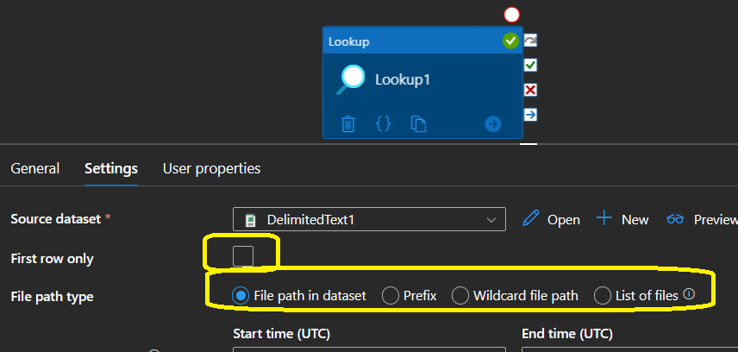

1. Debug Pipeline (Check your storage container 1st and make sure it has more than on1 file.
2. Note – output. It should be something like below based on what data you have in your container

Now try for more alteration using above solution. Note: Make sure, you have created new pipeline every time by just clone existing pipeline and rename it.

1. In just changed in your dataset with a specific file.

Run pipeline and Notes result

1. Now in this version, just changed “check box 1st rows only”. Run pipeline and note down output.
2. Also, Use Azure SQL database as source and see what option you are getting.